Handout 0.2: Draw/See/Hear Picture Cards and Room Map
Three parts. Part A is the room map, one per student. Part B is the six picture cards: print one set per pair, cut apart, and keep face down in an envelope. The cards are written as descriptions so the teacher can draw each one on the card before class (simple shapes only; a pencil sketch is fine). Part C is the comparison sheet, printed on the back of the map.

Part A: Room map
Name: ______________________ Date: __________ Period: ______
Before the tour: draw an X where you think the fire extinguisher is. Do not get up.
Directions during the tour: at each numbered stop, write the number and the name where it belongs on the map, and one word for the rule that goes with it.
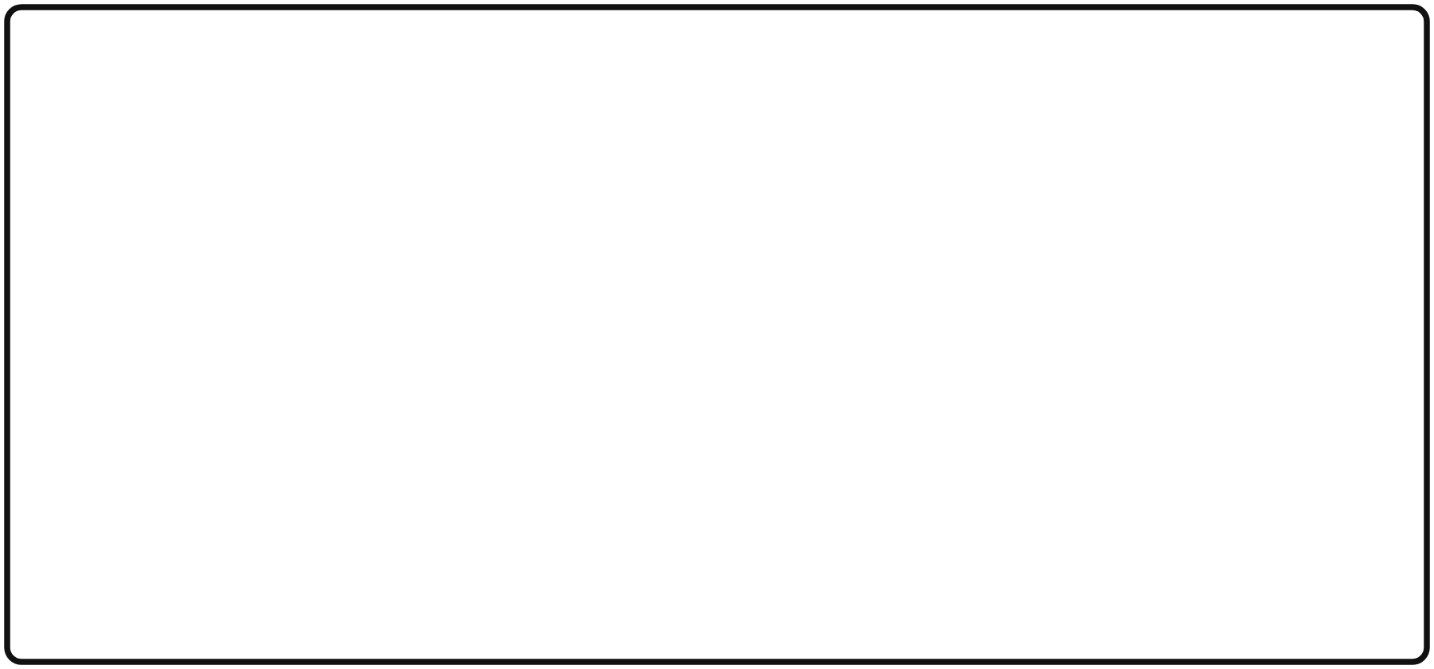
Room map: draw the room and number the tour stops
The ten stops (write each on the map):
Stop | Name | The one rule (one word or a few)
1 | Hand sink
2 | Kitchen station A (and the role card)
3 | First aid kit
4 | Fire extinguisher
5 | Exit (both exits and where we meet)
6 | Supply closet
7 | Sewing stations
8 | Safety Data Sheet (SDS) binder
9 | Trash and recycling
10 | Teacher desk and the turn-in tray
The reset cue, three words: ______________, ______________, ______________
Time it took the class today: ______ seconds. Goal by Friday: 3 seconds.
Word bank: hand sink (lavamanos); first aid kit (botiquín); fire extinguisher (extintor); exit (salida); supply closet (armario de suministros); station (estación).

Part B: The six picture cards
Directions for the teacher: draw each picture on a card with a pencil or a marker, exactly as described. Keep the drawings simple; the game is about words, not art. Card 1 is the easiest; card 6 is the hardest. Grade 6 pairs use cards 1 to 4.

Card 1: The house
A square house in the middle of the card. A triangle roof on top. A rectangle door in the middle of the bottom edge of the house. One round window in the top left corner of the house. A sun in the top right corner of the card. Three flowers in a row on the ground to the left of the house.

Card 2: The table
A long rectangle table in the middle of the card, seen from the side, with four legs. On top of the table, from left to right: a tall glass, a round plate, and a short candle with a flame. Under the table, on the left side, a cat sitting (a circle head, an oval body, a curved tail).

Card 3: The boat
A boat shaped like a half circle (flat side up) floating on a wavy line across the bottom third of the card. A tall mast (a straight line) in the middle of the boat with a triangle sail on the right side of the mast. Two birds (each a small letter M) in the top left corner. A cloud in the top right corner.

Card 4: The face
A big circle in the middle of the card. Two small circles for eyes, side by side, in the top half of the big circle. A triangle nose pointing down in the exact middle. A curved line smile in the bottom half. Three straight lines of hair sticking straight up from the top of the head. One ear, a small half circle, on the right side only.

Card 5: The kitchen counter
A long rectangle across the bottom half of the card (the counter). On the counter, from left to right: a bowl (a half circle, flat side up) with a spoon sticking out of it to the right; a tall bottle with a narrow neck; a stack of three plates (three flat ovals on top of each other). Above the counter, on the left, a square window with a cross in it (four panes). Above the counter, on the right, a round clock showing three o’clock.

Card 6: The map
A big square in the middle of the card with a smaller square inside it, in the top left corner of the big square (a room inside a building). A door, drawn as a short line with a curved swing, on the bottom edge of the big square, in the middle. Inside the small square, a star. Outside the big square, on the right, a tree (a trunk line with a round top). A dotted line path from the door to the tree. A compass in the top right corner of the card: a circle with an N above it.

Part C: Comparison sheet (back of the map)

Round 1
I was the: describer / drawer (circle one). Card number: ______
After you compare the drawing to the card, list two things the drawing got wrong and the word that was missing.
What the drawing got wrong | The word that was missing (position, size, count, or shape)

Round 2 (revised)
I was the: describer / drawer (circle one). Card number: ______
Precise words the describer used (at least three): ______________, ______________, ______________
Did the second drawing come out closer? Yes / No. Which words did it?
________________________________________________________________
Grade 8 stretch: write a three-step “recipe” for one card that a third student could draw from.
Step 1: ________________________________________________ Step 2: ________________________________________________ Step 3: ________________________________________________
Which lab role needs the most precise words, and why? ________________________________

Exit card
- One zone and its rule: ________________________________
- The reset cue in three words: ______________, ______________, ______________
- One precise word I will use next time I explain something: ______________

